|  |  |
| --- | --- |
| **Final Exam Practicum – Project Case** |  |
| COMP6681  Web Programming |
| **Computer Science** | **COMP6681-PROJECT-FEP-PPTI 9** |
| ***Valid on*** *2022, Odd Semester* | **Revision 00** |

1. Seluruh kelompok tidak diperkenankan untuk:

*The whole group is not allowed to:*

* + 1. Melihat sebagian atau seluruh proyek kelompok lain,

*Seeing a part of the whole project from another group*

* Tidak diperbolehkan untuk menyalin dari BUKU atau CATATAN, VIDEO dari pengajar (recording kelas, VBL, Youtube, dsb) dan REFERENSI lainnya

*Adapted a part of the whole project from any resources such as notes, videos (class recording, VBL, Youtube, etc), and other references*

* Mendownload sebagian maupun seluruh proyek dari internet (google, stackoverflow, dsb)

*Downloading a part of the whole project from the internet (google, StackOverflow, etc)*

* Mengerjakan soal yang tidak sesuai dengan tema yang ada di soal proyek,

*Working with another theme that is not in accordance with the existing theme in the matter of the project,*

* Melakukan tindakan kecurangan lainnya,

*Committing other dishonest actions,*

* Secara sengaja maupun tidak sengaja melakukan segala tindakan kelalaian yang menyebabkan hasil karyanya berhasil dicontek oleh orang lain / kelompok lain.

*Accidentally or intentionally conduct any failure action that causes the results of the project was copied by someone else / other groups.*

1. Jika kelompok terbukti melakukan tindakan seperti yang dijelaskan butir 1 di atas, maka **nilai kelompok** yang melakukan kecurangan (menyontek maupun dicontek) akan di – **NOL** – kan.

*If the group is proved to the actions described in point 1 above, the score of the group which committed dishonest acts (cheating or being cheated) will be “Zero”*

1. Perhatikan jadwal pengumpulan proyek, segala jenis pengumpulan proyek di luar jadwal tidak dilayani.

*Pay attention to the submission schedule for the project, all kinds of submission outside the project schedule will not be accepted*

1. Bila Anda tidak membaca peraturan ini, maka Anda dianggap telah membaca dan menyetujuinya

*If you have missed to read these regulations, so you are considered to have read and agreed on it*

1. Persentase penilaiaan untuk matakuliah ini adalah sebagai berikut:

*Marking percentage for this subject is described as follows:*

|  |
| --- |
| **UAP**  *Final Exam Practicum* |
| 100% |

1. Software yang digunakan pada matakuliah ini adalah sebagai berikut:

*Software will be used in this subject are described as follows:*

|  |
| --- |
| **Software**  *Software* |
| Chrome / Firefox / Microsoft Edge  Laravel Framework 8  PHP Composer 2.1.5  PHP Storm 2021.1.4  Visual Studio Code  XAMPP 8.0.7 |

## Ekstensi file yang harus disertakan dalam pengumpulan tugas mandiri, dan proyek untuk matakuliah ini adalah sebagai berikut:

*File extensions should be included in assignment and project collection for this subject are described as follows:*

|  |
| --- |
| **UAP**  *Final Exam Practicum* |
| Folder Project (PHP, SQL, Image Files (JPG / PNG), ENV, HTML, CSS, SCSS, JS, JSON, HTACCESS, ARTISAN) |

NOTE:

- admin gaada cart

- status added to cart tu kalau ada user yg masukkin property itu ke cart dia

- klo admin pencet finish di property yg added to cart, ntar semua cart yg ada property itu bakal dihapus

**- user: search bar -> search result page**

**- admin: search bar -> manage property page**

## Soal

*Case*

**megAWealth**

**megAWealth** is a real estate company that was founded in 2008. The owner of the company wanted a new web application and an API to compete with the other real estate companies. The new web application will be used as the online marketplace for **megAWealth**.

As a web developer, you are asked to create a web application using **Laravel** **8** for this online shop. There are three types of user’s role in this website: **Admin**, **Member**, and **Guest.**

* + - 1. **Login**

This is the page that allows user to log in to the website. If the user enters a wrong combination of email and password, then the website will show an error message.

If user entered a correct **Email** and **Password** combination, the page would redirect user to the home page. If the customer chooses **Remember Me**, then the website will save the user’s cookies for **5 minutes.** The following validation will be applied to the input fields:

|  |  |
| --- | --- |
| **Field** | **Information** |
| **Email Address** | Must be **filled** with **email validation** |
| **Password** | Must be **filled** and **minimum 8 characters length** |

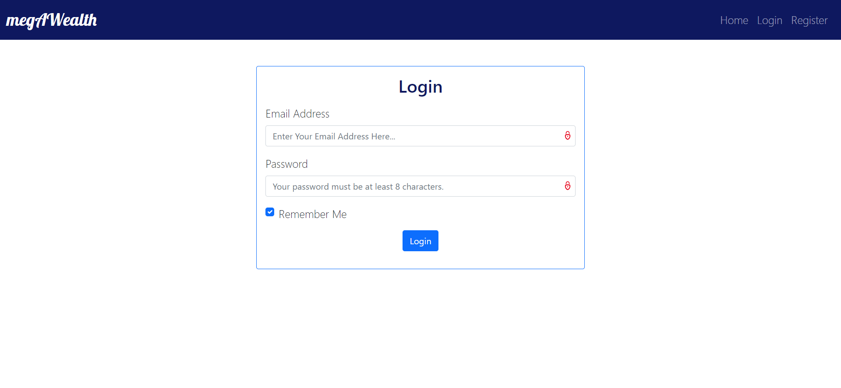

***Figure 1. Login Page***

1. **Register**

The customer can **register** themselves an account in this page. Each will be **validated** as shown below. If the customer inputted an **incorrect** **data**, then the page will show an **error** **message.** The following validation will be applied to each field:

|  |  |
| --- | --- |
| **Field** | **Information** |
| **Name** | Must be **filled** |
| **Email Address** | Must be **filled** with **email validation** and **unique** |
| **Password** | Must be **filled** and **minimum 8 characters length** |
| **Confirm Password** | Must be **filled** and **same with password** |

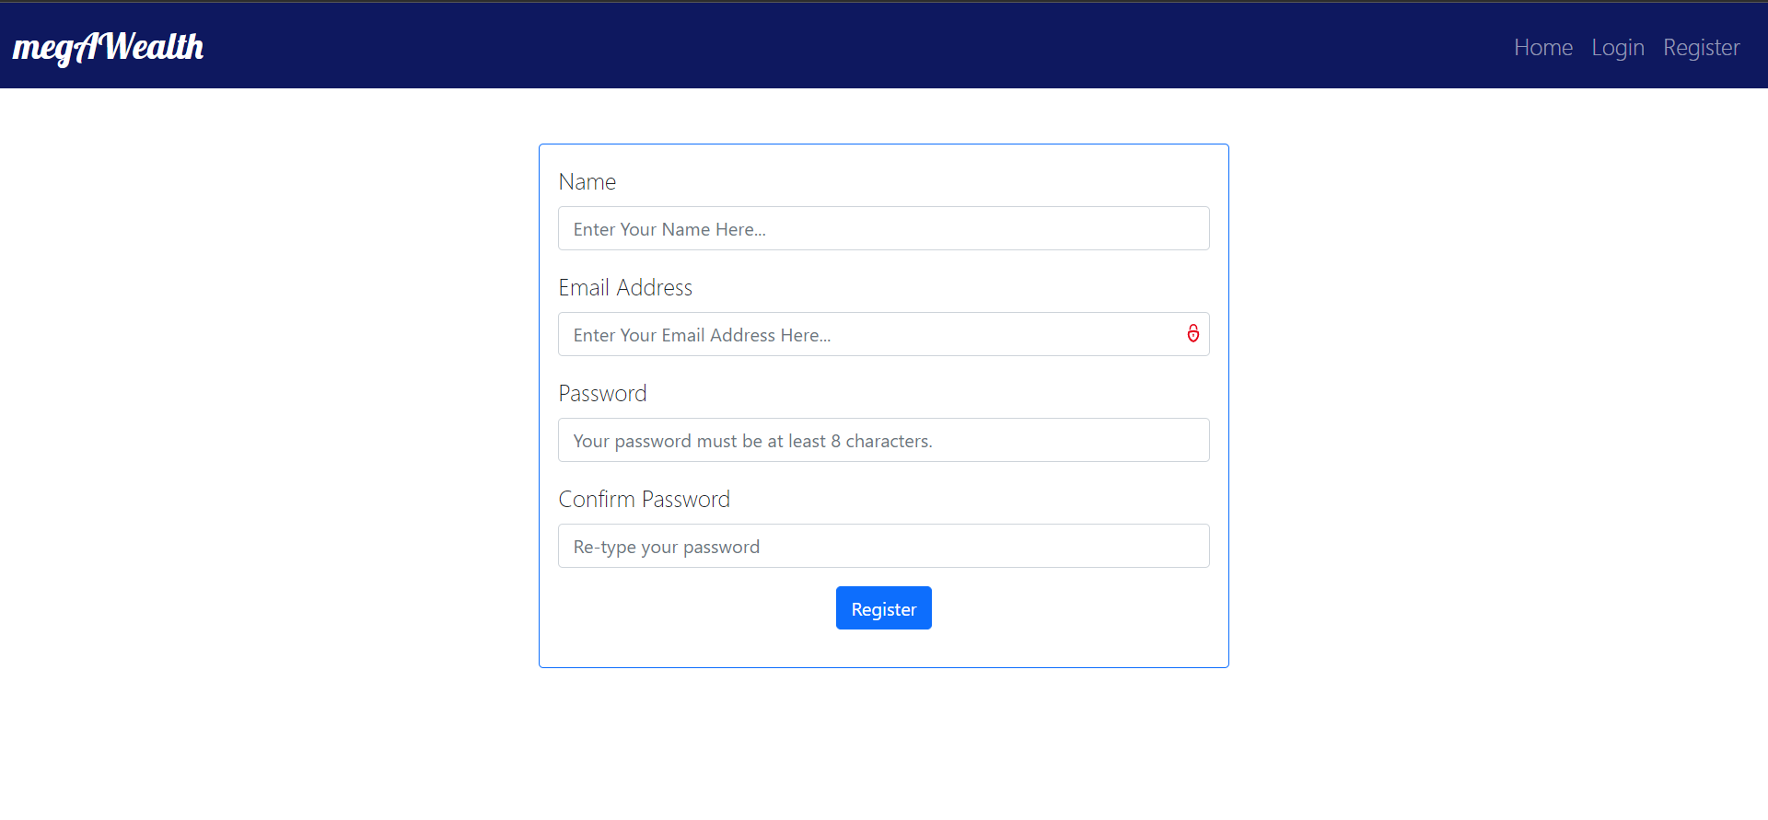

***Figure 2. Register Page***

1. **Home Page**

This page is where the user can search the **real estate** that the user wants. **All user** can access this page. The user will be able to **search by property location, property type, and type of sales.** The search results will be displayed in a separate page. The user can also navigate to **buy page, rent page, or about us page** by clicking the icons below the search bar.

In this page, guest can **Login** or **Register** to the page**,** this page can be accessed by **all of the users.** Logged in member will have extra button on the navigation bar, which is **Cart** and **Logout**. Meanwhile, admin will have extra button which is **Manage Company, Manage Real Estate, and Logout.**

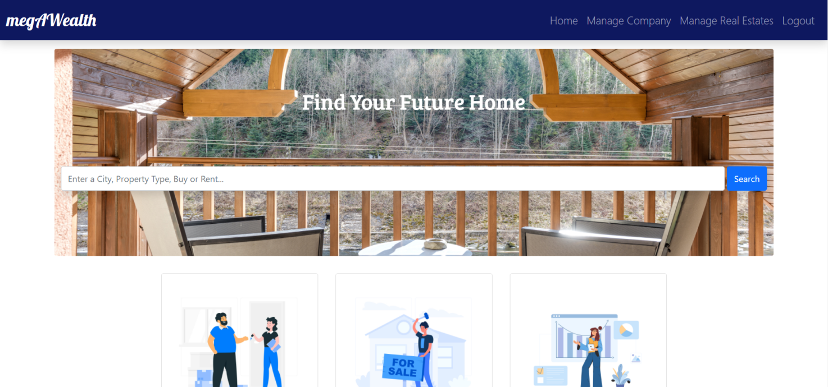

***Figure 3. Home Page (Member)***

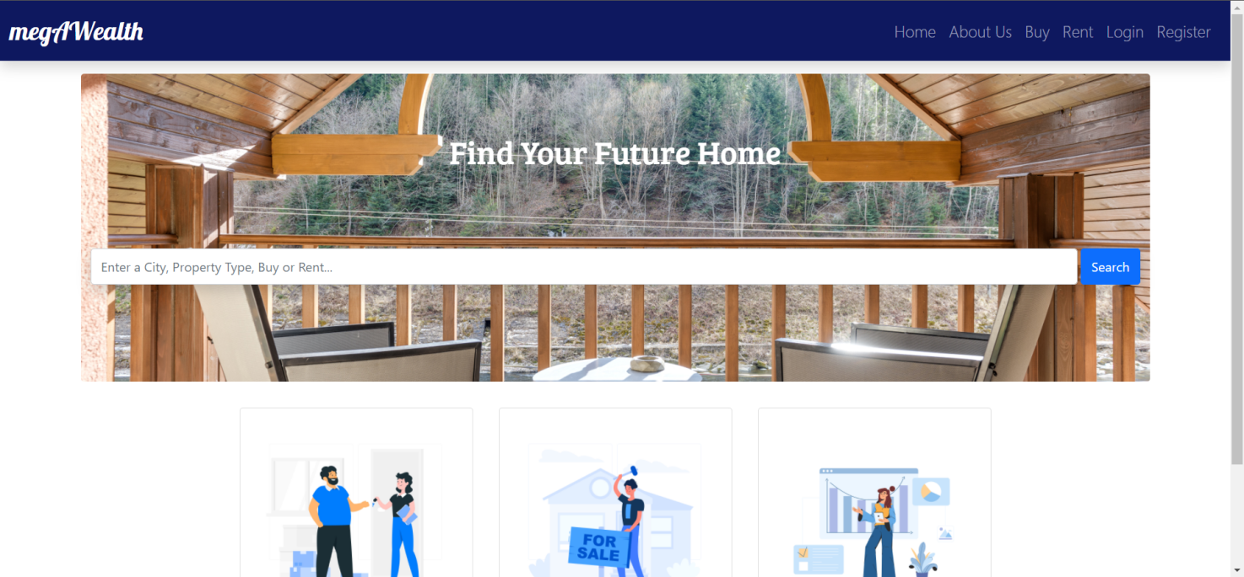

***Figure 4. Home Page (Guest)***

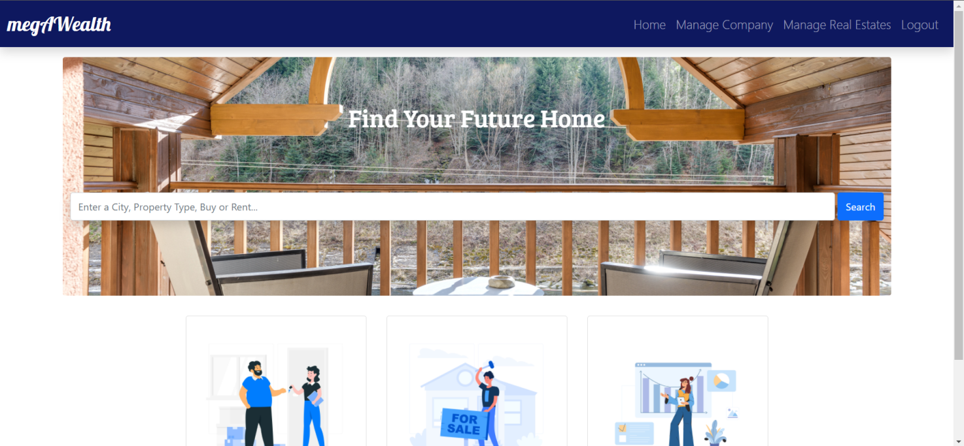

***Figure 5. Home Page (Admin)***

1. **Search Result Page**

This page is accessible for everyone. This page shows the real estate’s detail such as **price, address, image, property type, and the button to buy or rent.** The page will also be **paginated** to show **4 real estates** at a time.If the user has already logged in as a member, by clicking the buy or rent button, the user will be able to add the selected real estate to their cart. If the user has not logged in, the user will be redirected to the **Login Page**.

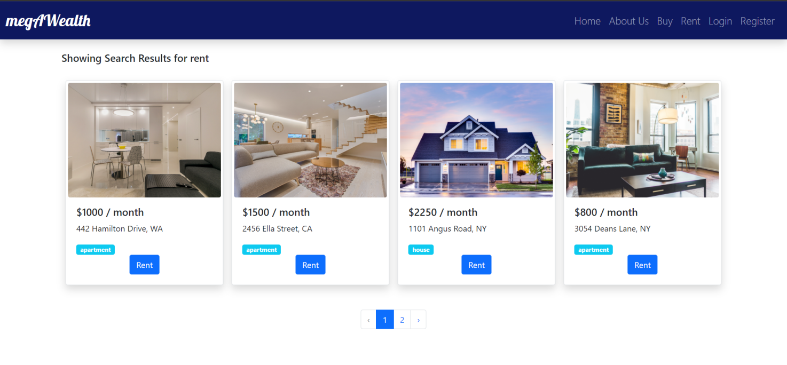

***Figure 6. Search Result Page (Guest)***

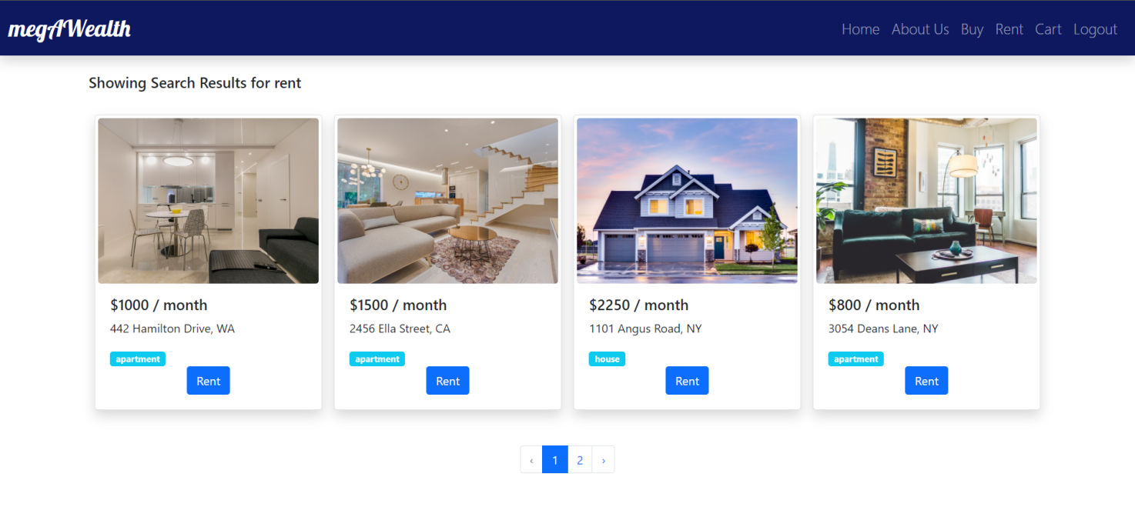

***Figure 7. Search Result Page (Member)***

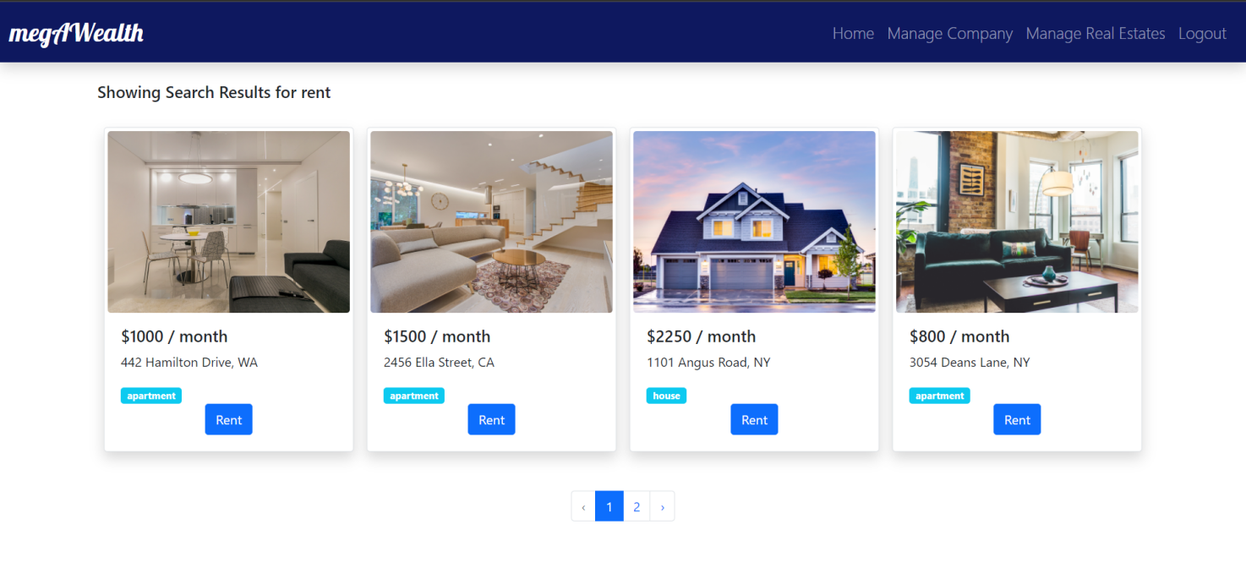

***Figure 8. Search Result Page (Admin)***

1. **About Us Page**

This page is accessible for guest and member. This page shows a short summary of **megAWealth** and **megAWealth**’s offices with its details such as **the image, office name, address, and contact information**. The offices shown will be **paginated** to show 5 offices at a time.



***Figure 9. About Us Page (Guest)***

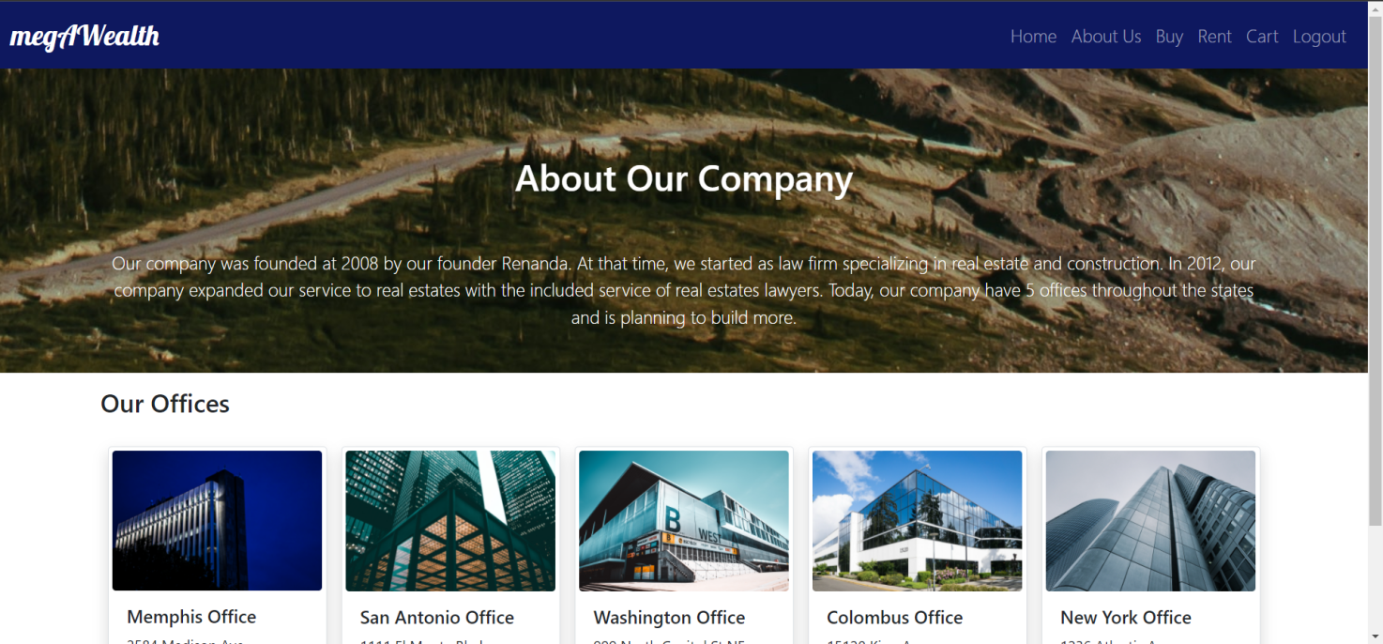

***Figure 10. About Us Page (Member)***

1. **Buy Page**

This page can be accessed by **member and guest.** This page shows the real estate(s) for sale. Each real estate will have details such as **the image, price, address, building type, and a button to buy.** The page will also be **paginated** to show 4 real estates at a time. If the user has already logged in as a member, by clicking the buy button, the user will be able to add the selected real estate to their cart. If the user has not logged in, the user will be redirected to the **Login Page**.

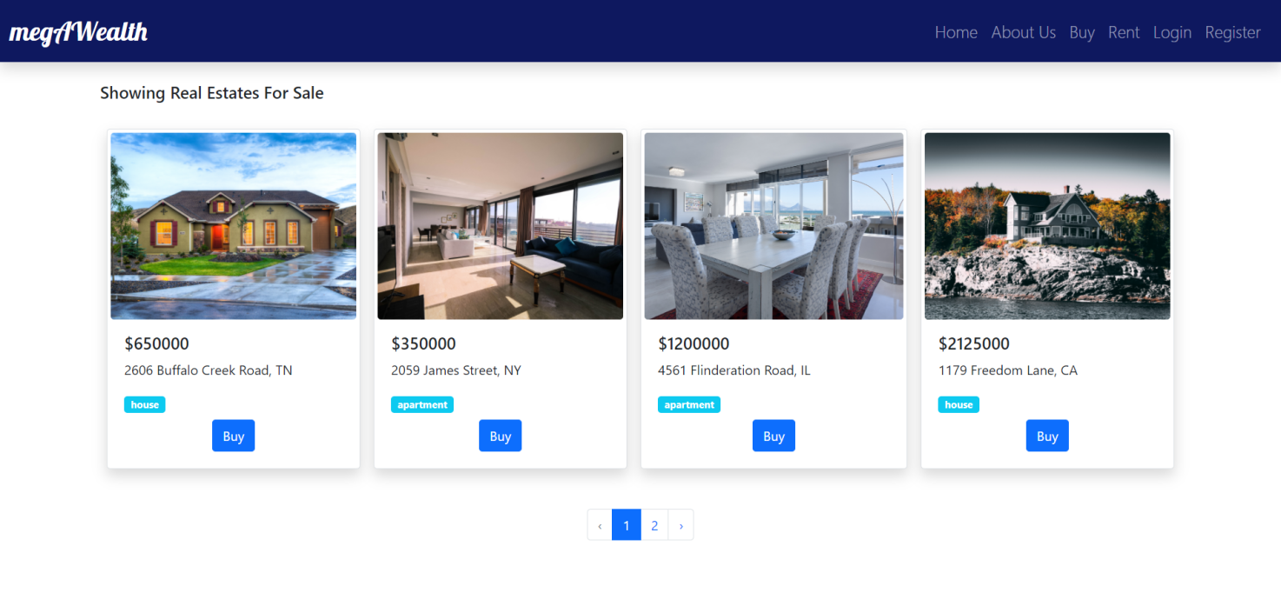

***Figure 11. Buy Page (Guest)***

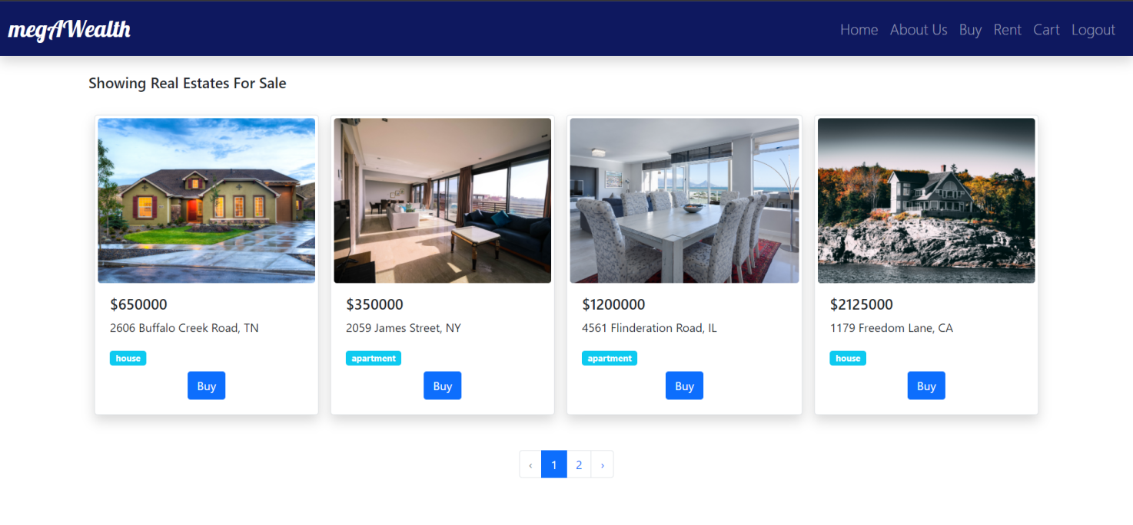

***Figure 12. Buy Page (Member)***

1. **Rent Page**

This page can be accessed by **member and guest.** This page shows the real estate(s) for rent. Each real estate will have details such as **the image, price, address, building type, and a button to buy.** The page will also be **paginated** to show 4 real estates at a time. If the user has already logged in as a member, by clicking the rent button, the user will be able to add the selected real estate to their cart. If the user has not logged in, the user will be redirected to the **Login Page**.

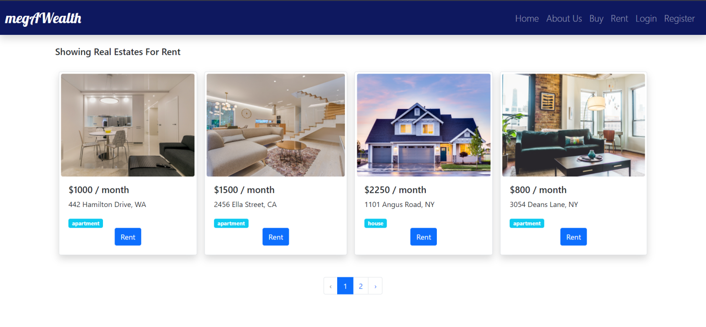

***Figure 13. Rent Page (Guest)***

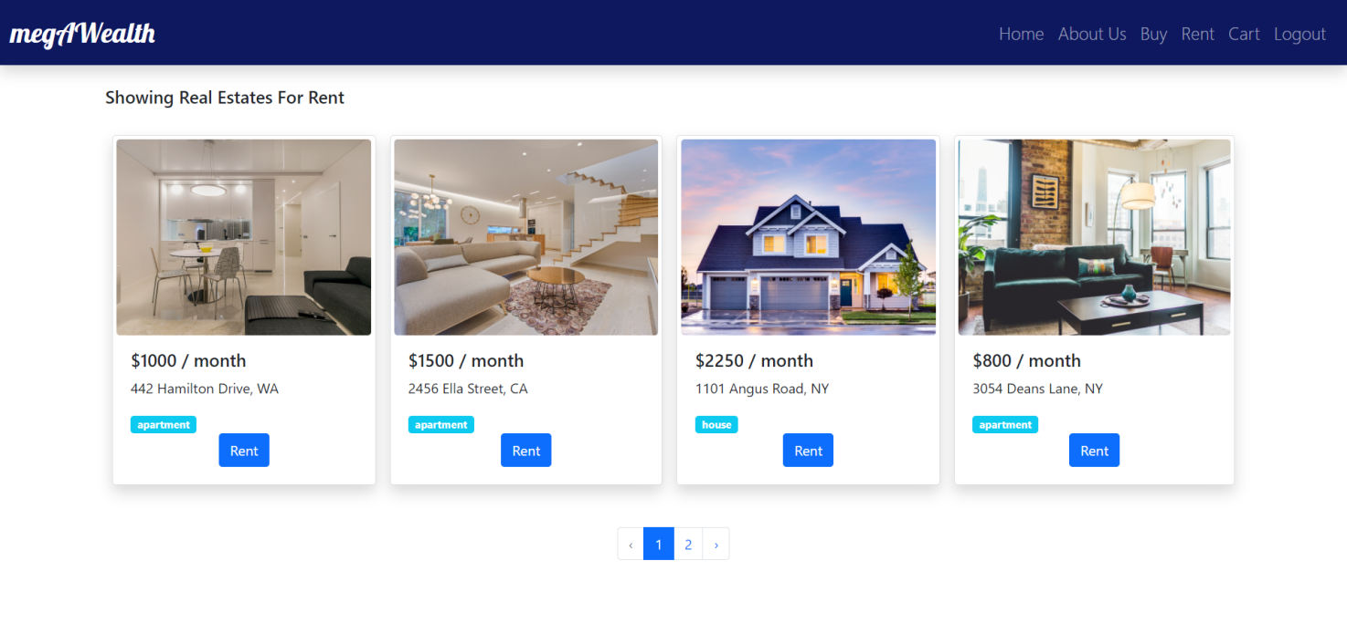

***Figure 14. Rent Page (Member)***

1. **Cart Page**

This page can only be accessible to member. This page shows the real estate(s) that the user added to cart by clicking buy or rent button. This page will also be using **pagination** to show 4 real estates at a time. Each real estate shown will have details such as the **image, price, address, building type, added to cart date, and a cancel button.** The page will also have a **checkout button.** By pressing the cancel button, the real estate will be removed from the cart. By pressing the checkout button, the transaction will be complete and the user will be redirected to the home page with a checkout successful message.

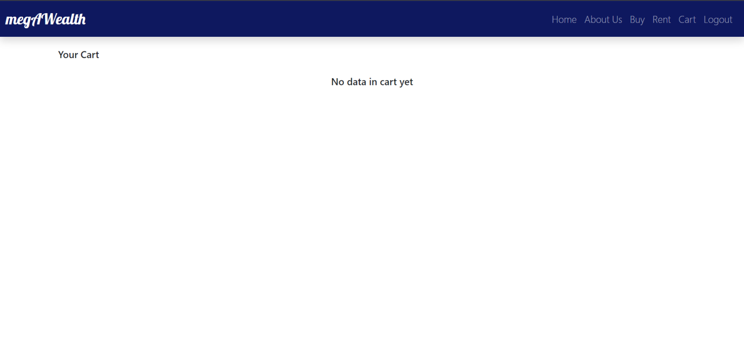

***Figure 15. Cart Page If Empty (Member)***

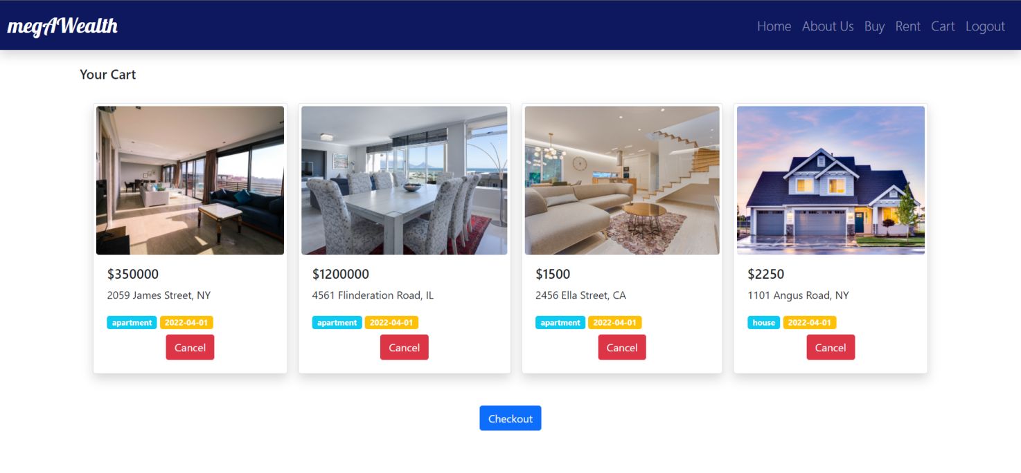

***Figure 16. Cart Page (Member)***

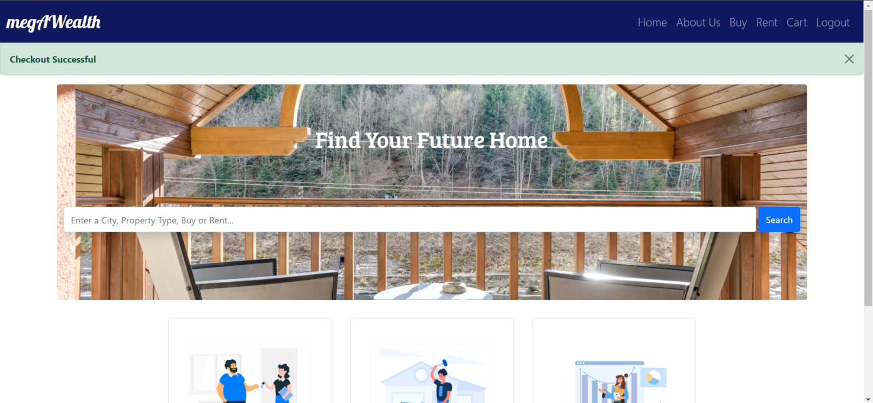

***Figure 17. Home Page with Checkout Success Message (Member)***

1. **Manage Company Page**

This page is only accessible to admin. The page will show the current office(s) of the company using **pagination** to show 4 office at a time. Each displayed real estate will have details such as **image, office name, address, contact information, update button, and delete button.** The page will also have a button to add a new office. By pressing the add office button, the user will be redirected to the **Add Office Page.** By pressing the update office button, the user will be redirected to **Update Office Page.** By pressing the delete button, the office will be removed.

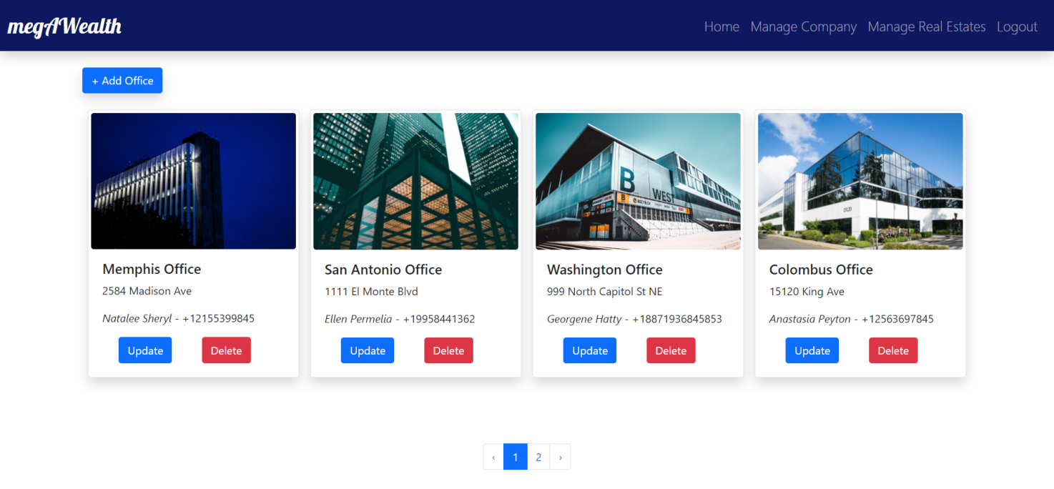

***Figure 18. Manage Company Page (Admin)***

1. **Add Office Page**

This page is only accessible to admin. This page will ask for a number of details and a Insert Button to add a new office. The admin must input **Office Name, Office Address, Contact Name, Phone Number, and Image.** The following validation will be applied to each field:

|  |  |
| --- | --- |
| **Field** | **Information** |
| **Office Name** | Must be **filled** |
| **Office Address** | Must be **filled** |
| **Contact Name** | Must be **filled** |
| **Phone Number** | Must be **filled** |
| **Image** | Must be **filled,** max. **10MB,** and with extensions of .jpeg, .jpg, or .png |

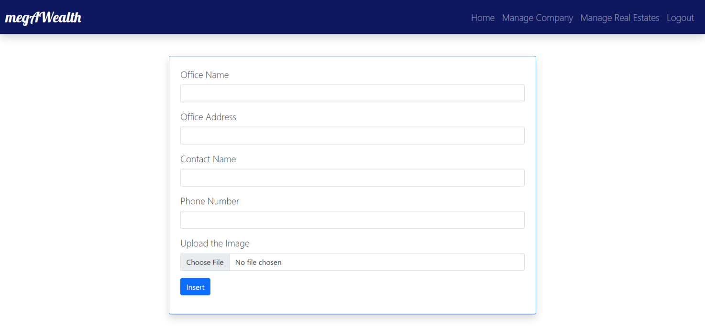

***Figure 19. Add Office Page (Admin)***

1. **Update Office Page**

This page is only accessible to admin. This page will display the image of the office and the input field to edit the details about the office. The admin will be able to edit details such as **Office Name, Office Address, Contact Name, and Phone Number.** The same validation for adding a new office will also be applied to this page.

|  |  |
| --- | --- |
| **Field** | **Information** |
| **Office Name** | Must be **filled** |
| **Office Address** | Must be **filled** |
| **Contact Name** | Must be **filled** |
| **Phone Number** | Must be **filled** |

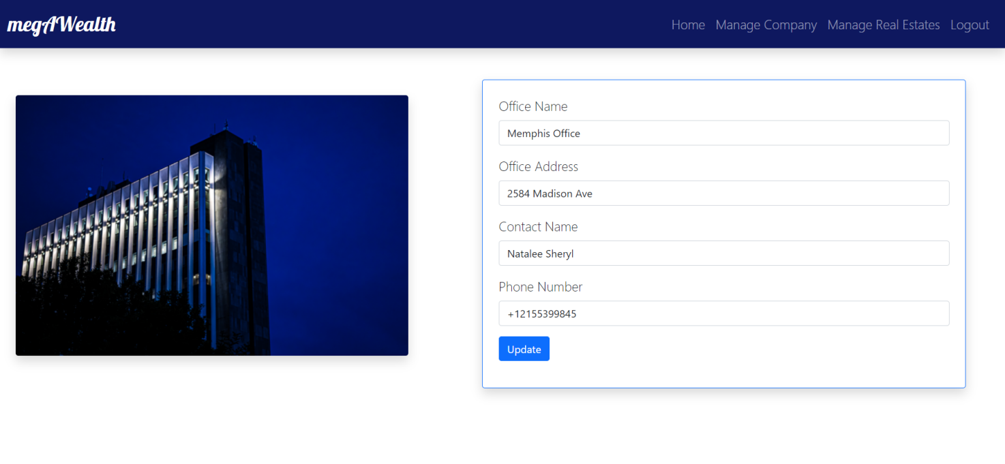

***Figure 20. Update Office Page (Admin)***

1. **Manage Real Estate Page**

This page is only accessible to admin. This page will show all real estate(s) available with details such as **image, price, building type, type of sales, status (open for rent/sale, added to cart, or transaction completed), finish button (only for real estate with added to cart status), update button, and delete button.** This page will also have a button to add real estate. The page will display 4 real estate at a time using **pagination.** By pressing the add real estate button, the user will be redirected to **Add Real Estate Page.** By pressing the update button, the user will be redirected to **Update Real Estate Page.** By pressing the delete button, the real estate will be removed from the web application. By pressing the finish button, the real estate will have the status of completed transactions.

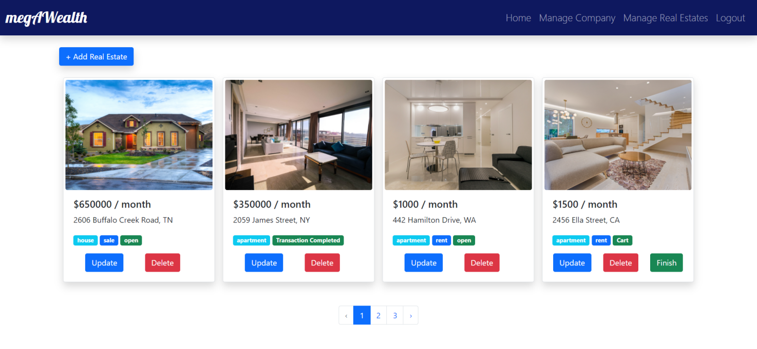

***Figure 21. Manage Real Estate Page (Admin)***

1. **Add Real Estate Page**

This page is only accessible to admin. The admin will be able to add a new real estate by inputting several details of the real estate such as **Sales Type, Building Type, Price, Location, and Image.** The following validation will be applied to each field:

|  |  |
| --- | --- |
| **Field** | **Information** |
| **Sales Type** | Must be **filled, between Sale or Rent** |
| **Building Type** | Must be **filled, between House or Apartment** |
| **Price** | Must be **filled** |
| **Location** | Must be **filled** |
| **Image** | Must be **filled,** max. 10MB, and with extensions of .jpeg, .jpg, or .png. |

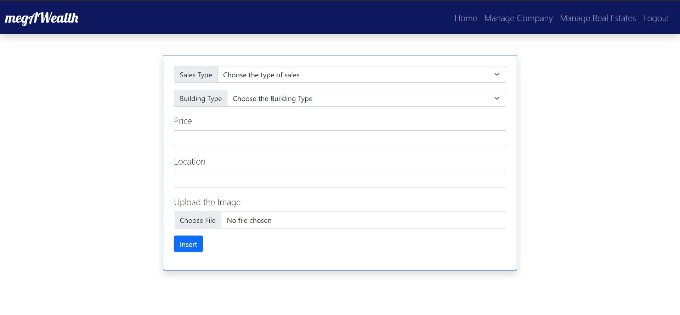

***Figure 22. Add Real Estate Page (Admin)***

1. **Update Real Estate Page**

This page is only accessible to admin. This page will display the image of the office and the input field to edit the details about the office. The admin will be able to edit details such as **Sales Type, Building Type, Price, and Location.** The same validation for adding a new real estate will also be applied to this page.

|  |  |
| --- | --- |
| **Field** | **Information** |
| **Sales Type** | Must be **filled, between Sale or Rent** |
| **Building Type** | Must be **filled, between House or Apartment** |
| **Price** | Must be **filled** |
| **Location** | Must be **filled** |

1. **Logout**

This button can only be pressed to logged in users. By clicking the Logout button, the user will be logged out and redirected to the login page.

Besides the web application, you are asked to create **Application Programming Interface (API)** using **Laravel Passport** and only need to be tested using **Postman**, below is the API details:

1. **Register Endpoint**

This endpoint will provide user registration feature. The endpoint will receive number of inputs such as **name, email, and password.** The following validation will apply to the inputs:

|  |  |
| --- | --- |
| **Field** | **Information** |
| **Name** | Must be **filled** |
| **Email** | Must be **filled with Email Validation and Unique** |
| **Password** | Must be **filled,** Minimum **8 Characters** |

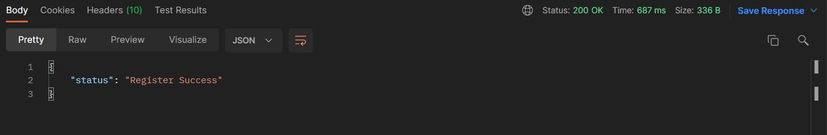

***Figure 23. Register Endpoint (Success)***

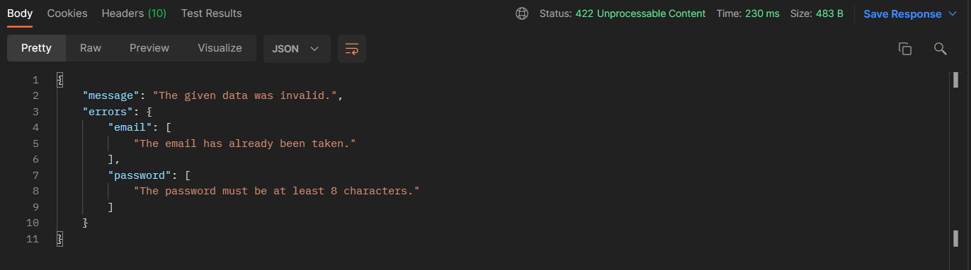

***Figure 23. Register Endpoint (Errors)***

1. **Login Endpoint**

This endpoint will provide login feature. The endpoint will receive two inputs such as **email and password.** Upon successful login, the user will receive a **bearer token**. The following validation will apply to the inputs:

|  |  |
| --- | --- |
| **Field** | **Information** |
| **Email** | Must be **filled with email validation** |
| **Password** | Must be **filled,** Minimum **8 characters.** |

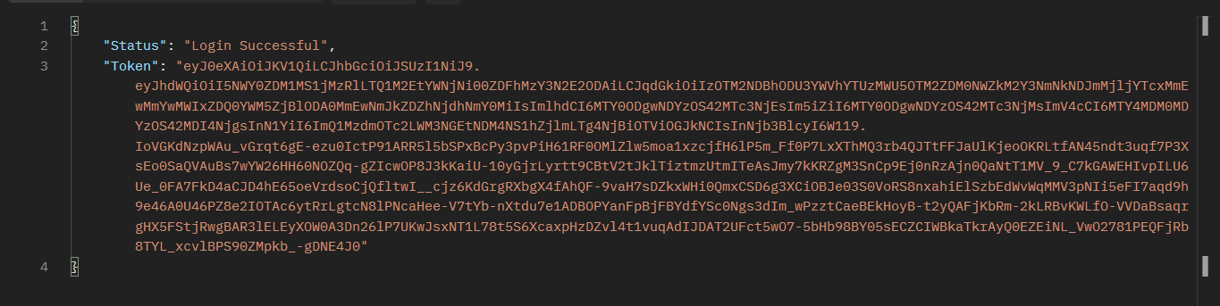

***Figure 23. Login API (Successful)***

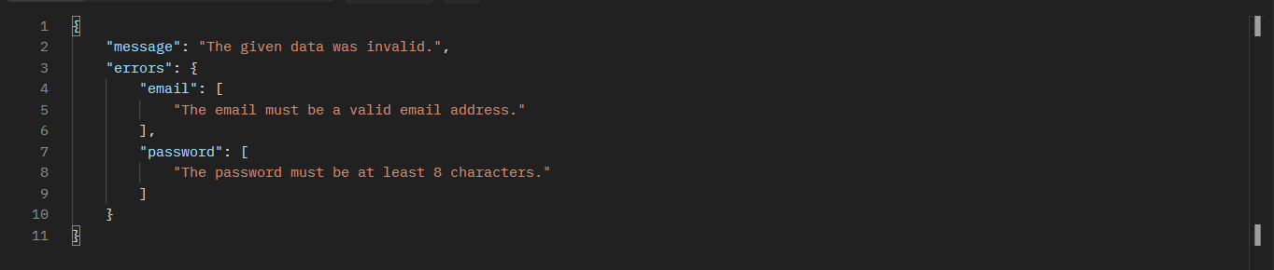

***Figure 24. Login Endpoint (Errors)***

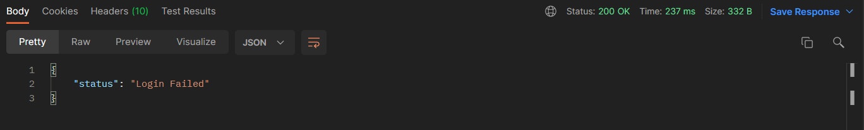

***Figure 25. Login Endpoint (Invalid Credential)***

1. **Transaction Endpoint**

This endpoint provided the access to the transaction data of a specific user. To get the transaction data, the user must provide the token received on Login. The endpoint will also receive an **email.** The following validation will apply to the **email** input:

|  |  |
| --- | --- |
| **Field** | **Information** |
| **Email** | Must be **filled with Email Validation** |

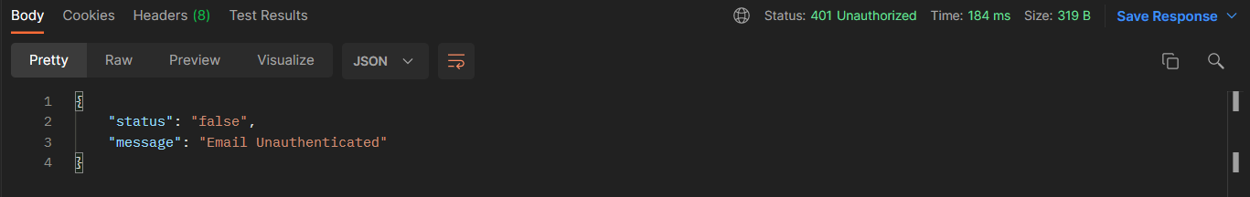

***Figure 26. Transaction Endpoint (Wrong Token)***

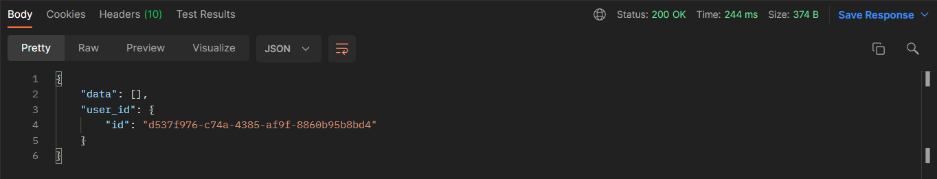***Figure 27. Transaction Endpoint (No Transaction)***

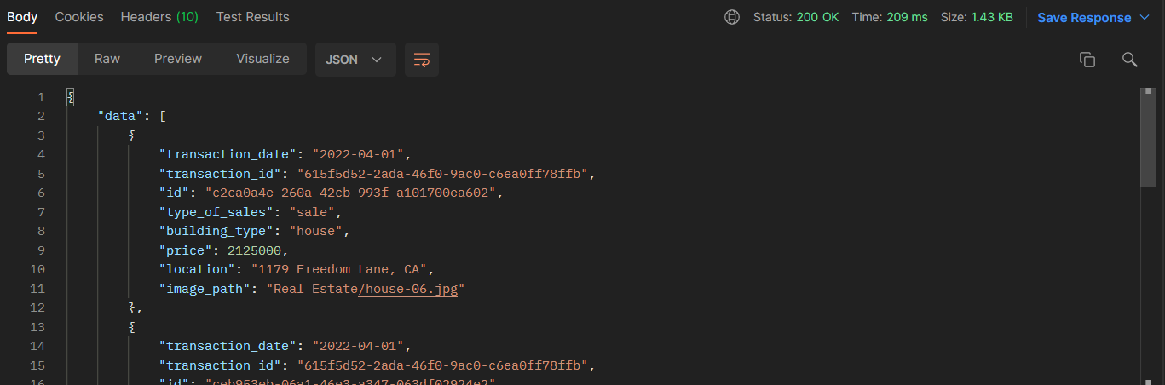***Figure 27. Transaction Endpoint (Successful)***

General Provisions:

1. Use **MySQL** asdatabase and must using **Laravel Migration** features.
2. **All file upload** feature such as image and document must be **stored to server storage**.
3. Use PHP Framework **Laravel 8** to build the project.
4. Use Laravel **MVC** concept (**Model, View, Controller**) to build the project.
5. Use **Eloquent Query / Query Builder** to work with database.
6. You are free to design your own database table **based on given requirements**.
7. Print screen given below is only an example. You are free to create your own user interfaces.
8. It is **prohibited** to install any kind of Laravel packages. You must use fresh installation of **Laravel 8**.
9. Only **validation** in the **backend** (using Laravel) will be graded.
10. Use **Laravel Passport** for creating API.

Here are the rules that you must follow to create your project:

1. Use appropriate software, maximum file size, and collect appropriate files for this subject based on **Academic Book** that can be downloaded from **PPTI x SLC Practicum Website**.
2. Include the other files that can support your project, such as:
   * Other files (image, audio, video, etc.) used in your project.
   * *.DOC file (documentation of your project) that contains all pages in your project, reference links of additional files (image, audio, video, etc.) used in your project, the description about how to use your application, etc.
3. If there are some hidden creativities, please note them in the existing documentation because they can greatly affect your project score.

**If you do not understand, please ask your assistant! Do not make your own assumption!**